Scripting Language Lab

Submitted by:

Jotham N. Wanniang

Registration no: 201900343

Sec: C

**Question:**

Q. Create a personal website having following areas (The wire-frame is given below as in image)

* Header
* Navigation Menu
* Left Sidebar
* Content Area
* Footer Area
* (All pages mentioned in the diagram (or something similar) must be created)

**HTML Code:**

**Page 1:**

<!DOCTYPE html>

<html>

<head>

<title> Lamborghini Urus </title>

<meta name="viewport" content="width=device-width, initial-scale=1.0">

<style>

body {

background-color: black;

}

ul.menu{

background-color: black;

padding: 5px;

overflow: visible;

display: flex;

justify-content: center;

}

ul.menu li{

list-style: none;

display: inline;

font-size: 20px;

margin-left: 110px;

margin-right: 100px;

overflow: hidden;

float: left;

padding-left: 5px;

padding-right: 20px;

}

ul.menu li a{

text-decoration: none;

color: white;

display: block;

text-align: center;

padding: 5px 5px;

}

li a:hover {

background-color: black;

}

div.urus{

background-image:

linear-gradient(to bottom, rgba(192,192,192,0.52), rgba(169,169,169,0.73)),

url('https://stimg.cardekho.com/images/carexteriorimages/930x620/Lamborghini/Urus/4418/Lamborghini-Urus-V8/1621927166506/front-left-side-47.jpg');

width: 97%;

height: 1200px;

background-size: cover;

color: white;

padding: 20px;

margin-left: 3px;

}

h1.logo{

font-size: 70px;

text-align: right;

margin-right: 30px;

margin-top: 10px;

color: white;

}

div.logo{

position: absolute;

top: 40px;

left: 0px;

}

h2.urus{

font-size: 50px;

margin-left: 30px;

color: wheat;

}

h1.motto{

font-size: 60px;

text-align: left;

margin-left: 20px;

color: wheat;

}

h2.description{

font-size: 25px;

margin-left: 30px;

margin-top: 30px;

color: white;

}

ul.specifications li{

list-style: none;

font-size: 20px;

margin-left: 35px;

color: white;

}

p.description{

font-size: 20px;

margin-left: 70px;

color: white;

}

div.left{

margin-top: 0;

width: 50%;

float: left;

}

div.right{

margin-top: 38%;

width: 50%;

float: left;

}

div.L{

margin-top: 0;

width: 25%;

float: left;

color: black;

}

div.M{

margin-top: 0;

width: 25%;

float: left;

color: black;

}

div.R{

margin-top: 0;

width: 50%;

float: left;

color: black;

}

</style>

</head>

<body>

<ul class="menu">

<li class="active"><a href="Home.html"> Home </a></li>

<li><a href="Summary.html"> Summary </a></li>

<li><a href="Variants.html"> Variants </a></li>

<li><a href="Images.html"> Images </a></li>

<li><a href="Colour.html"> Colour </a></li>

</ul>

<div class="urus">

<div class="logo">

<img src = "https://www.freepnglogos.com/uploads/lamborghini-logo-png/lamborghini-logo-wallpapers-pictures-images-1.png" width=300 height=200 >

</div>

<h1 class="logo"> Lamborghini Urus </h1>

<br>

<hr>

<div class="left">

<h2 class="urus"> Urus </h2>

<h1 class="motto"> UNLOCK ANY ROAD </h1> <br><br>

<h2 class="description"> Overview </h2>

<p class="description">

The soul of a super sports car and the functionality of an SUV: Lamborghini Urus is the first Super Sport Utility Vehicle in the world.

With extreme proportions, breathtaking design, extraordinary driving dynamics and heart-pounding performance, Urus represents freedom in its quintessential state.

You can experience any road, from track to the sand, ice, gravel or rocks, thus unlocking any road. You can explore any new terrain, thus expressing yourself.

</p>

<h2 class="description"> Exterior </h2>

<p class="description">

Its design assumes multiple guises: sporty, elegant and off-road. Muscular surfaces lend a decisive appearance, while the massive tires and wheels impart the look of a luxury super sports car.

Every surface places a focus on functionality. The signature style of Lamborghini is immediately recognizable, with details such as Y-shaped and hexagonal details,

the front hood with center peak, and the crossed lines on the rear hood. Urus is the lowest SUV in its segment.

</p>

<h2 class="description"> Interior </h2>

<p class="description">

The luxury of Italian craftsmanship meets state-of-the-art technology. Aerospace-inspired design and driver-oriented instrumentation, featuring three TFT screens, make the driving experience more comfortable and engaging.

The interior can be customized and made even more sporty or elegant, thanks to the wide range of colors and materials: leather, Alcantara, wood, aluminum or carbon-fiber finishes.

</p>

</div>

<div class="right">

<h2 class="description"> Key Specifications </h2>

<ul class="specifications">

<li><b> Fuel Type:</b> Petrol </li>

<li><b> Engine:</b> 3996 cc </li>

<li><b> Power and Torque:</b> 650 bhp & 850 Nm </li>

<li><b> Drive Train:</b> AWD </li>

</ul>

<h2 class="description"> Price </h2>

<p class="description">

Lamborghini Urus price is ₹3.10 Crore. The price of Petrol version for Urus is ₹3.10 Crore.

</p>

<!-- h2><a href="https://www.google.com/search?q=lamborghini+urus+news&rlz=1C1CHBD_enIN939IN939&source=lnms&tbm=nws&sa=X&ved=2ahUKEwi2xdP-3oHzAhWAxjgGHcF-D_YQ_AUoAXoECAEQAw&biw=1536&bih=731"> Lamborghini Urus News </a></h2 -->

<h2 class="description"><a href="https://www.youtube.com/watch?v=QtBDL8EiNZo"> Lamborghini Urus News </a></h2>

</div>

<br>

<hr>

<div class="L">

<h3> Mobile </h3>

<h4> +91 098 7654321 </h4>

</div>

<div class="M">

<h3> Email </h3>

<h4> lamborghini@gmail.com </h4>

</div>

<div class="R">

<h3> Copyright © 2021 Automobili Lamborghini S.p.A. a sole shareholder company part of Audi Group. </h3>

<h4> All rights reserved. VAT no. IT 00591801204 </h4>

</div>

</div>

</body>

</html>

**Page 2:**

<!DOCTYPE html>

<html>

<head>

<title> Summary </title>

<meta name="viewport" content="width=device-width, initial-scale=1.0">

<style>

body {

background-color: lightgrey;

}

ul.menu{

background-color: grey;

padding: 5px;

overflow: visible;

display: flex;

justify-content: center;

}

ul.menu li{

list-style: none;

display: inline;

font-size: 20px;

margin-left: 110px;

margin-right: 100px;

overflow: hidden;

float: left;

padding-left: 5px;

padding-right: 20px;

}

ul.menu li a{

text-decoration: none;

color: white;

display: block;

text-align: center;

padding: 5px 5px;

}

li a:hover {

background-color: grey;

}

div.urus{

background-image:

linear-gradient(to bottom, rgba(192,192,192,0.52), rgba(169,169,169,0.73)),

url('https://cdn-ds.com/blogs-media/sites/492/2020/06/06094945/2021-Lamborghini-Urus-Pearl-Capsule-in-Arancio-Borealis-Exterior-Driver-Side-Profile_o-1038x350.jpg');

width: 70%;

height: 300px;

background-size: cover;

color: white;

padding: 20px;

margin-left: 210px;

}

div.interior{

background-image:

linear-gradient(to bottom, rgba(192,192,192,0.52), rgba(169,169,169,0.73)),

url('https://static.toiimg.com/photo/imgsize-927600,msid-85391201/85391201.jpg');

width: 70%;

height: 400px;

background-size: cover;

color: white;

padding: 20px;

margin-left: 210px;

}

div.exterior{

background-image:

linear-gradient(to bottom, rgba(192,192,192,0.52), rgba(169,169,169,0.73)),

url('https://live.staticflickr.com/4654/38767442385_0ffe282cba_b.jpg');

width: 70%;

height: 400px;

background-size: cover;

color: white;

padding: 20px;

margin-left: 210px;

}

h1.summary{

font-size: 60px;

text-align: center;

margin-left: 20px;

color: white;

font-family: "Garamond", serif;

}

h2.description{

font-size: 25px;

margin-left: 30px;

margin-top: 30px;

color: white;

}

p.description{

font-size: 20px;

margin-left: 70px;

color: white;

}

</style>

</head>

<body>

<ul class="menu">

<li class="active"><a href="Home.html"> Home </a></li>

<li><a href="Summary.html"> Summary </a></li>

<li><a href="Variants.html"> Variants </a></li>

<li><a href="Images.html"> Images </a></li>

<li><a href="Colour.html"> Colour </a></li>

</ul>

<div class="urus">

<h1 class="summary"> Summary </h1>

<p class="description">

Lamborghini takes a giant leap ahead and changes the way we look at SUVs with the launch of the Urus.

Named after a species of wild Ox that predates the modern domestic cattle, the Urus is Lamborghini’s second SUV that comes nearly 25 years after their first SUV, the LM002, went out of production.

It is based on the same MLB Evo platform as the Porsche Cayenne, Bentley Bentayga and the Audi Q7 under the VW Group umbrella.

</p>

</div>

<div class="interior">

<br><br>

<h2 class="description"> Interior </h2>

<p class="description">

The Urus SUV gets everything that one could expect from a Lamborghini. Although highly customisable, the cabin is sporty and functional.

There are two digital screens on the centre console, while instrument cluster is all-digital too. The fighter-jet-style ANIMA drive selector has five driving modes – Strada, Sport, Corsa, Sabbia (sand), Terra (land), and Neve (snow).

Of these, the last three are seen for the first time in a car from Sant’Agata Bolognese. Although the Urus is a proper four-seater, the SUV can be had with a five-seat configuration as well with 18-way adjustable seats, ISOFIX, and sunroof.

The Urus has a 616 litres boot space which can be extended to 1,596 litres.

</p>

</div>

<div class="exterior">

<h2 class="description"> Exterior </h2>

<p class="description">

Lamborghini Urus has every bit of the supercar DNA with all those chiseled creases and in-your-face styling. The SUV flaunts flared wheel arches with body claddings all around and massive 23-inch wheels (largest in its segment) wrapped in bespoke Pirellis.

Moreover, the Urus gets the biggest brakes ever fitted on a production SUV.

</p>

<h2 class="description"> Engine </h2>

<p class="description">

Mechanically, the Urus is powered by a 4.0-litre turbocharged V8 that generates a massive 650bhp of power at 6,000rpm and 850Nm of turning force accessible from as low as 2250rpm.

The Italian SUV is capable of sprinting from 0-100kmph in a sportscar-shaming 3.6 seconds and on to a top whack of 305kmph making it the fastest SUV on sale today.

Transmission is an eight-speed automatic sending power to all four wheels through Tamburo – Lamborghini’s dynamic control.

</p>

</div>

</div>

</body>

</html>

**Page 3:**

<!DOCTYPE html>

<html>

<head>

<title> Variants </title>

<meta name="viewport" content="width=device-width, initial-scale=1.0">

<style>

body {

background-color: lightgrey;

}

ul.menu{

background-color: grey;

padding: 5px;

overflow: visible;

display: flex;

justify-content: center;

}

ul.menu li{

list-style: none;

display: inline;

font-size: 20px;

margin-left: 110px;

margin-right: 100px;

overflow: hidden;

float: left;

padding-left: 5px;

padding-right: 20px;

}

ul.menu li a{

text-decoration: none;

color: white;

display: block;

text-align: center;

padding: 5px 5px;

}

li a:hover {

background-color: grey;

}

div.urus{

background-image:

linear-gradient(to bottom, rgba(192,192,192,0.52), rgba(169,169,169,0.73)),

url('https://images.indianexpress.com/2021/03/lamborghini-urus-1200.jpg');

width: 97%;

height: 500px;

background-size: contain;

color: white;

padding: 20px;

margin-left: 3px;

background-repeat: no-repeat;

background-position: right;

}

table.variants{

color: black;

border-spacing: 10px;

margin-left: 10px;

}

</style>

</head>

<body>

<ul class="menu">

<li class="active"><a href="Home.html"> Home </a></li>

<li><a href="Summary.html"> Summary </a></li>

<li><a href="Variants.html"> Variants </a></li>

<li><a href="Images.html"> Images </a></li>

<li><a href="Colour.html"> Colour </a></li>

</ul>

<div class="urus">

<table class="variants">

<tr>

<th> Variants </th>

<th> Ex-showroom Price </th>

</tr>

<tr>

<td> Urus Twin-Turbo V8 <br> 3996 cc, Petrol, Automatic (Dual Clutch) </td>

<td> ₹3.10 Crore </td>

</tr>

<tr>

<td> Urus Twin-Turbo V8: Pearl Capsule <br> 3996 cc, Petrol, Automatic (Dual Clutch) </td>

<td> ₹3.43 Crore </td>

</tr>

</table>

</div>

</body>

</html>

**Page 4:**

<!DOCTYPE html>

<html>

<head>

<title> Images </title>

<meta name="viewport" content="width=device-width, initial-scale=1.0">

<style>

body {

background-color: lightgrey;

}

ul.menu{

background-color: grey;

padding: 5px;

overflow: visible;

display: flex;

justify-content: center;

}

ul.menu li{

list-style: none;

display: inline;

font-size: 20px;

margin-left: 110px;

margin-right: 100px;

overflow: hidden;

float: left;

padding-left: 5px;

padding-right: 20px;

}

ul.menu li a{

text-decoration: none;

color: white;

display: block;

text-align: center;

padding: 5px 5px;

}

li a:hover {

background-color: grey;

}

div.main{

max-width: 2000px;

margin: auto;

background: grey;

overflow: auto;

}

div.gallery{

margin: 5px;

border: 1px solid white;

float: left;

width: 390px;

margin-left:250px;

}

div.gallery img{

width: 100%;

height: auto;

}

div.caption{

padding: 15px;

text-align: center;

color: white;

}

</style>

</head>

<body>

<ul class="menu">

<li class="active"><a href="Home.html"> Home </a></li>

<li><a href="Summary.html"> Summary </a></li>

<li><a href="Variants.html"> Variants </a></li>

<li><a href="Images.html"> Images </a></li>

<li><a href="Colour.html"> Colour </a></li>

</ul>

<div class="main">

<div class="gallery">

<img src="https://images.indianexpress.com/2021/03/lamborghini-urus-1200.jpg">

<div class="caption"> Lamborghini Urus </div>

</div>

<div class="gallery">

<img src="https://besthqwallpapers.com/Uploads/19-6-2018/56156/thumb2-lamborghini-urus-2018-exterior-side-view-luxury-sport-suv.jpg">

<div class="caption"> Side View </div>

</div>

<div class="gallery">

<img src="https://i.pinimg.com/originals/bc/77/1b/bc771b371c2e0d6c9216c64b1b3028e3.jpg">

<div class="caption"> Front View </div>

</div>

<div class="gallery">

<img src="http://www.carmagram.com/wp-content/uploads/2017/12/2018-Lamborghini-Urus-SUV-Yellow-Exterior-Rear-View.jpg">

<div class="caption"> Rear View </div>

</div>

<div class="gallery">

<img src="https://live.staticflickr.com/4654/38767442385_0ffe282cba_b.jpg">

<div class="caption"> Engine </div>

</div>

<div class="gallery">

<img src="https://www.lamborghini.com/sites/it-en/files/DAM/lamborghini/facelift_2019/model_detail/urus/connected_car/connected_urus_m.jpg">

<div class="caption"> Interior </div>

</div>

<div class="gallery">

<img src="https://pictures.topspeed.com/IMG/crop/202009/lamborghini-urus-gra_800x0w.jpg">

<div class="caption"> Pearl Capsule Edition </div>

</div>

<div class="gallery">

<img src="https://www.lamborghini.com/sites/it-en/files/DAM/lamborghini/facelift_2019/model_detail/gateway_urus/graphite/2021/02_24_restyle/urus_graphite_over_01_m.jpg">

<div class="caption"> Granite Capsule Edition </div>

</div>

</div>

</body>

</html>

**Page 5:**

<!DOCTYPE html>

<html>

<head>

<title> Colour </title>

<meta name="viewport" content="width=device-width, initial-scale=1.0">

<style>

body {

background-color: lightgrey;

}

ul.menu{

background-color: grey;

padding: 5px;

overflow: visible;

display: flex;

justify-content: center;

}

ul.menu li{

list-style: none;

display: inline;

font-size: 20px;

margin-left: 110px;

margin-right: 100px;

overflow: hidden;

float: left;

padding-left: 5px;

padding-right: 20px;

}

ul.menu li a{

text-decoration: none;

color: white;

display: block;

text-align: center;

padding: 5px 5px;

}

li a:hover {

background-color: grey;

}

div.main{

max-width: 2200px;

margin: 10px;

background: lightgrey;

overflow: auto;

}

div.gallery{

margin: 20px;

float: left;

width: 230px;

margin-left: 35px;

}

div.gallery img{

width: 100%;

height: auto;

clip-path: circle();

}

div.caption{

padding: 15px;

text-align: center;

color: black;

}

</style>

</head>

<body>

<ul class="menu">

<li class="active"><a href="Home.html"> Home </a></li>

<li><a href="Summary.html"> Summary </a></li>

<li><a href="Variants.html"> Variants </a></li>

<li><a href="Images.html"> Images </a></li>

<li><a href="Colour.html"> Colour </a></li>

</ul>

<div class="main">

<div class="gallery">

<img src="https://cdn-ds.com/blogs-media/sites/94/2018/01/27205604/Lamborghini-Urus-Blu-Astraeus-color_o.jpg">

<div class="caption"> Blu Astraeus </div>

</div>

<div class="gallery">

<img src="https://cdn-ds.com/blogs-media/sites/94/2018/01/27205606/Lamborghini-Urus-Nero-Helene-color_o.jpg">

<div class="caption"> Nero Helene </div>

</div>

<div class="gallery">

<img src="https://cdn-ds.com/blogs-media/sites/94/2018/01/27205605/Lamborghini-Urus-Grigio-Lynx-color_o.jpg">

<div class="caption"> Grigio Lynx </div>

</div>

<div class="gallery">

<img src="https://cdn-ds.com/blogs-media/sites/94/2018/01/27205603/Lamborghini-Urus-Bianco-Monocerus-color_o.jpg">

<div class="caption"> Bianco Monocerus </div>

</div>

<div class="gallery">

<img src="https://cdn-ds.com/blogs-media/sites/94/2018/01/27205604/Lamborghini-Urus-Giallo-Auge-color_o.jpg">

<div class="caption"> Giallo Auge </div>

</div>

</div>

</body>

</html>

**Homepage:**

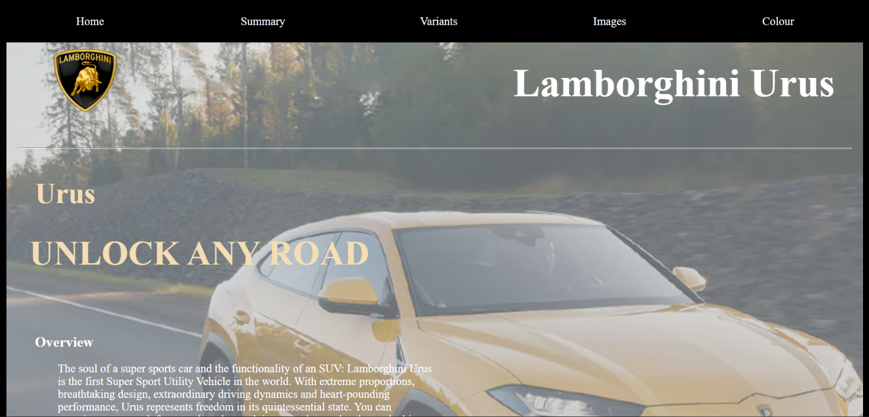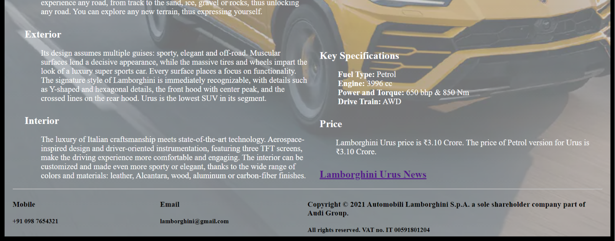

**Summary:**

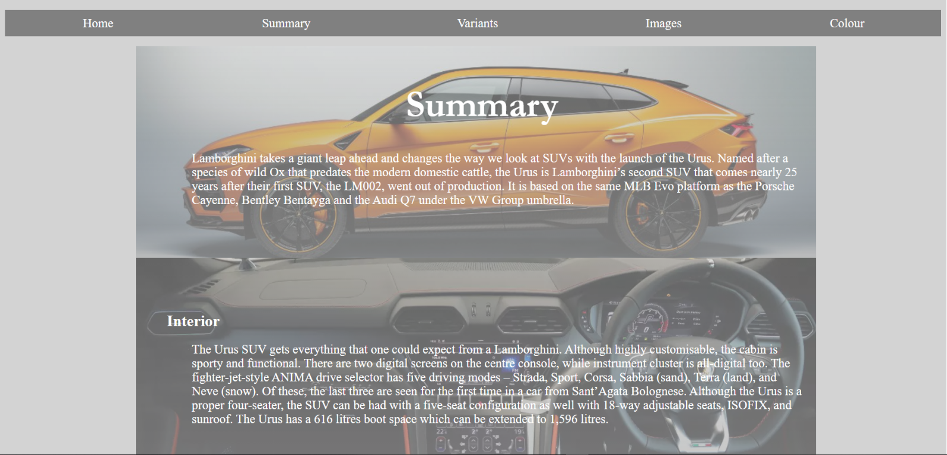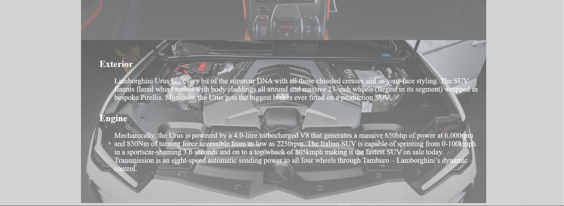

**Variants:**

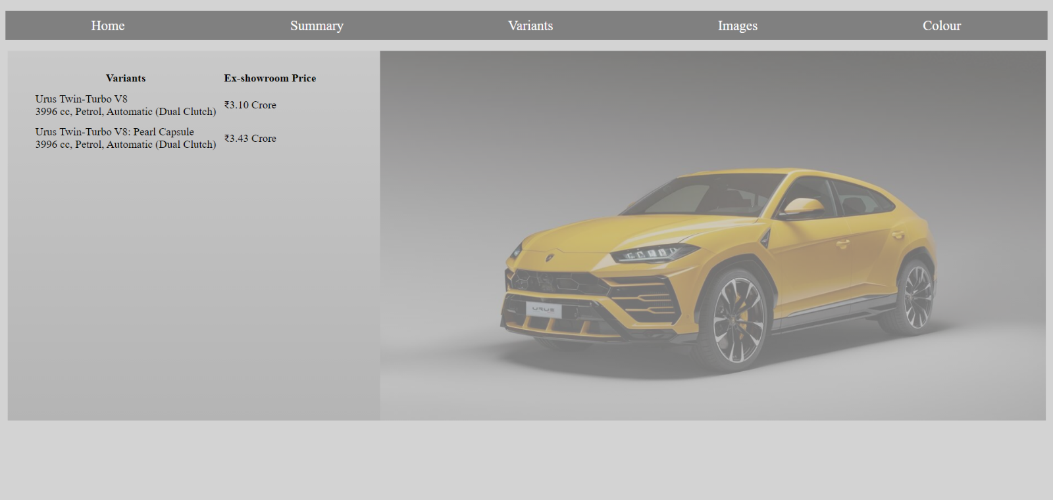

**Images:**

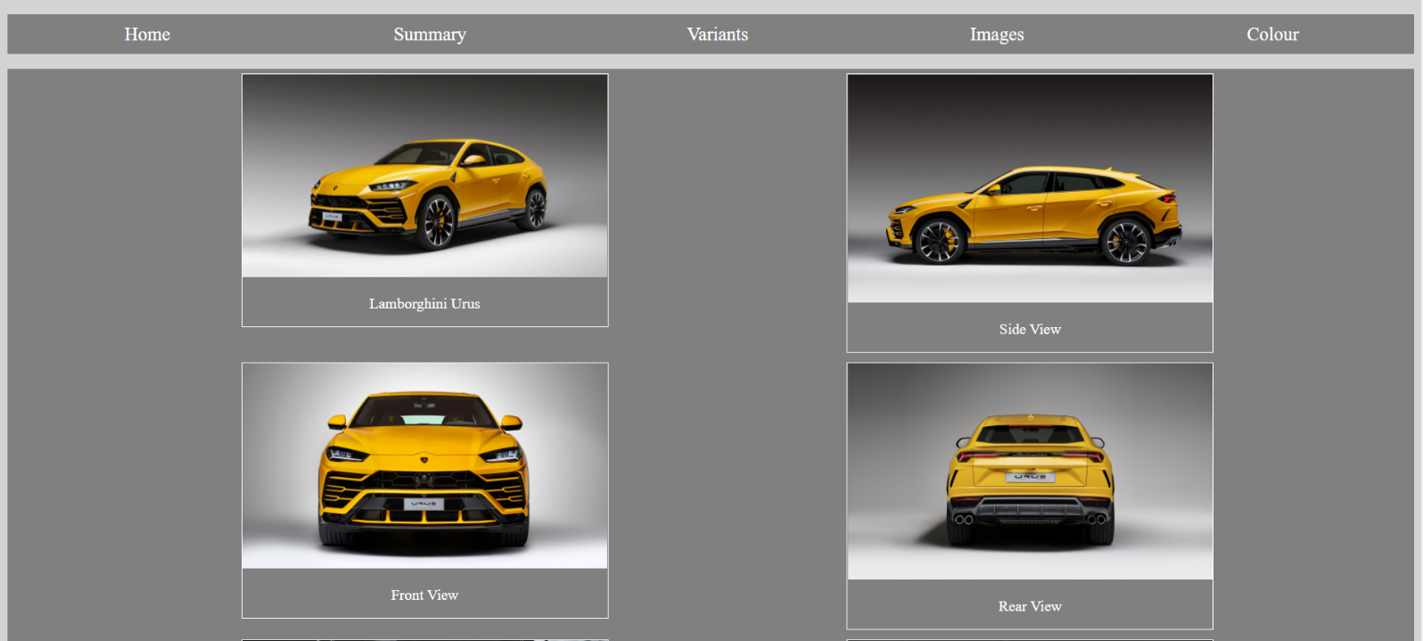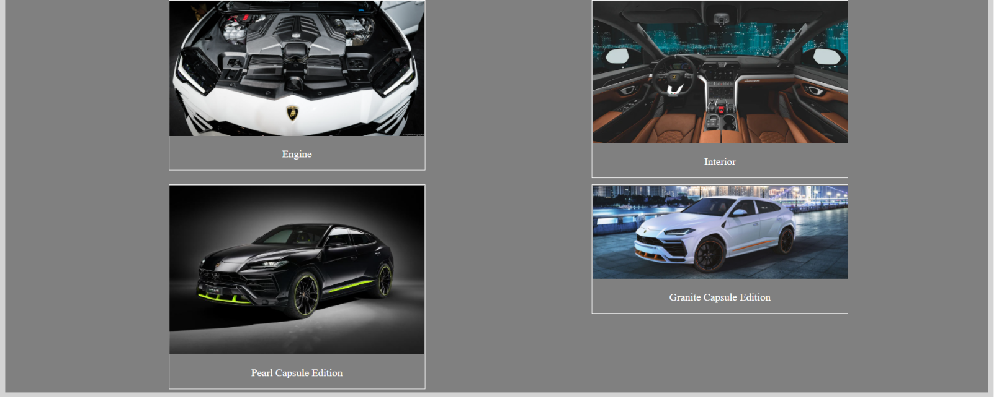

**Colour**:

